How to Download Pre-populated
Billing Documents via LegalServer.

Several billing documents are available through LegalServer that can be prepopulated with case information.
All documents are located under DOCUMENT TEMPLATES towards the bottom of the screen in the Case Overview page.
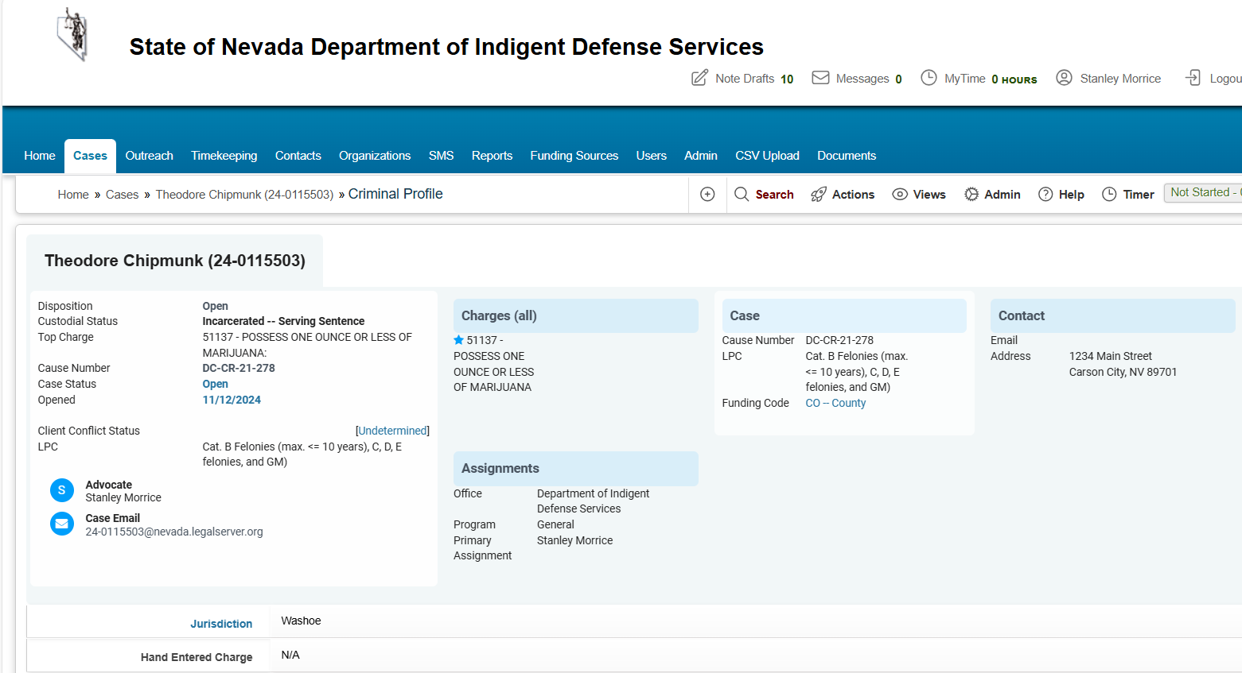
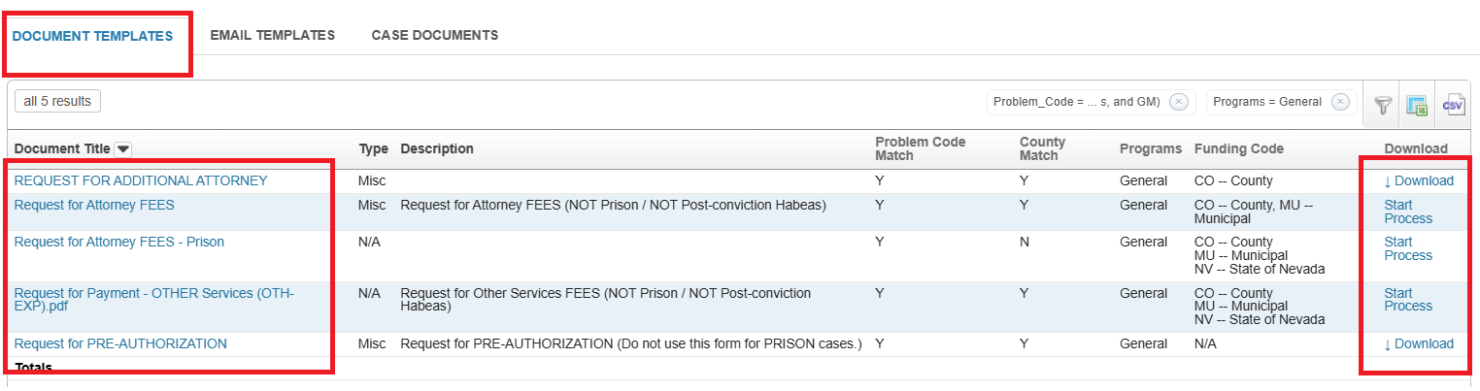

If you select the link under Document Title the form will download to your computer.
If you select the Start Process on the far right you will be able to pre-populate the form with information from the case.

The following steps are needed when processing a pre-populated billing form:
Go to case overview page.
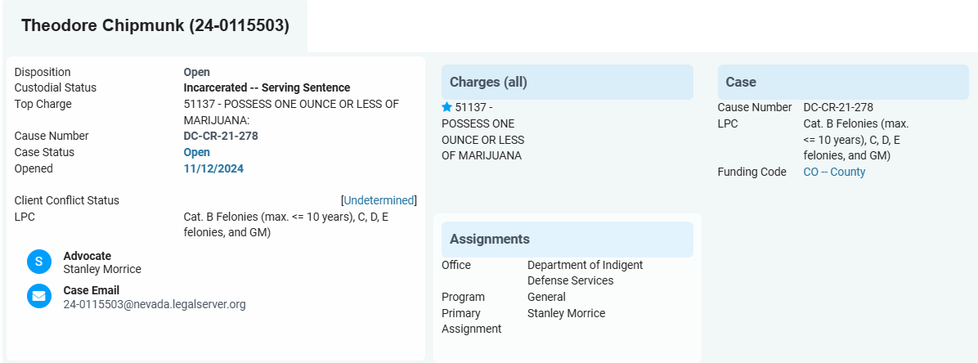

Then scroll towards bottom of page to find the Document Templates tab.
Select Start Process for Request for Attorney FEES.
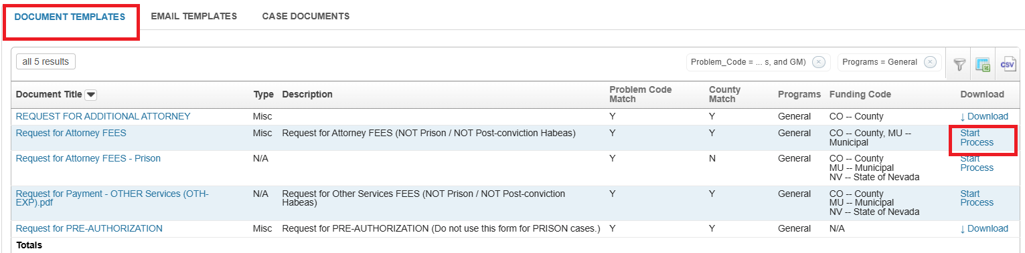

Select Continue.
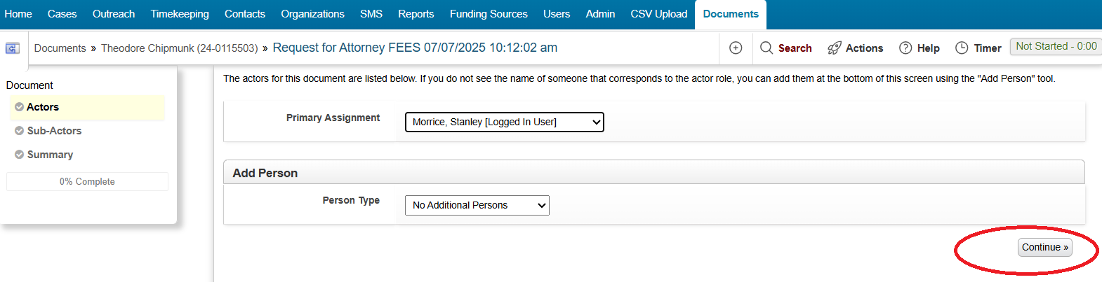
Select Continue.
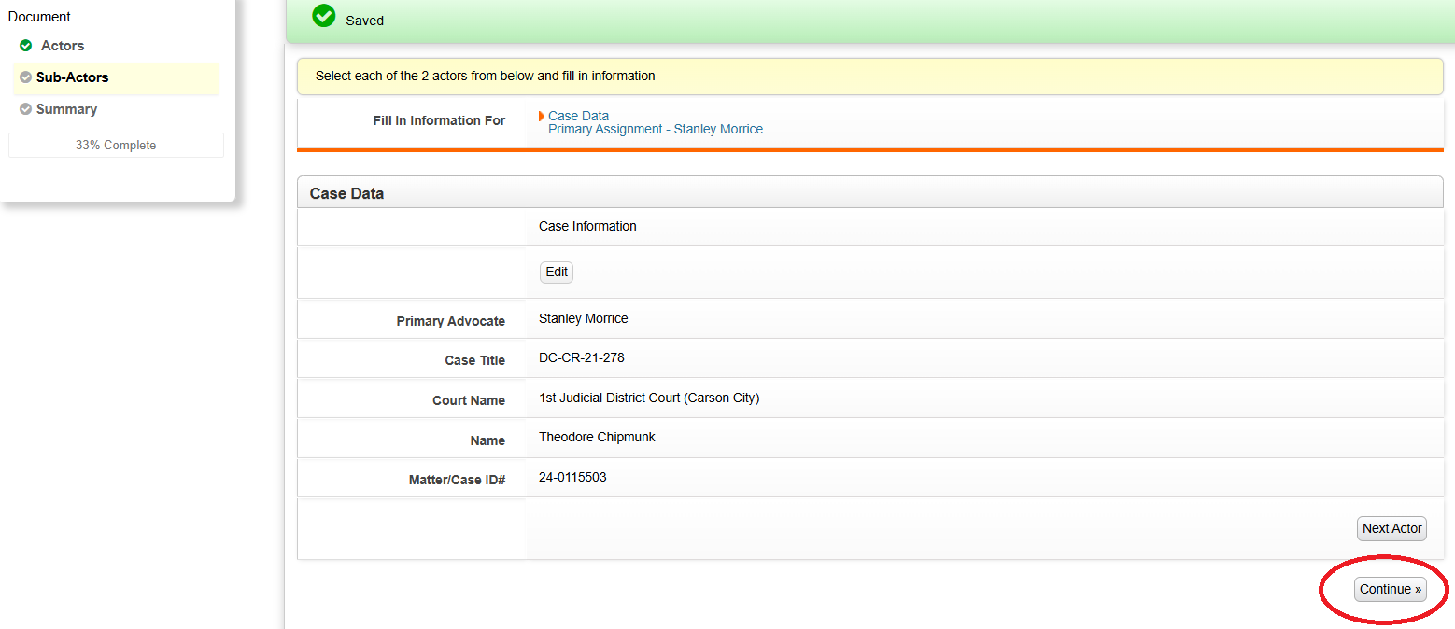

In order to view the newly created pdf go to the link labeled You can download it by clicking here. A download should begin to your computer or laptop.

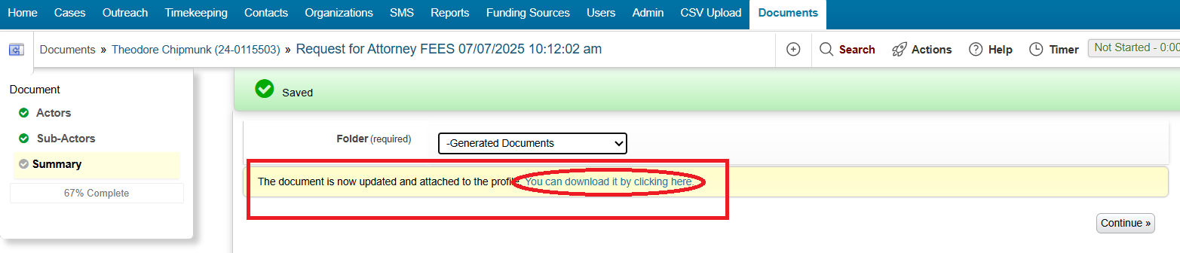

Completed form should be downloaded with some pre-populated fields completed. Any edits or missing information can be made to the pdf prior to submission.
